NOTE: This protocol is adapted from the original protocol from Thao Truong in the Bernhardt Lab at HMS Dept. of Microbiology. Massive thanks to Thao for sharing this protocol and helping with initial troubleshooting.

**Materials**

Use DAP at final concentration 300 uM in plates and liquid media

* Sigma 33240-1G (2,6-Diaminopimelic acid))
* Make 60 mM solution in 50 mL water, dissolve by vigorous stirring, store at 4C

Millipore MFilters

* 0.45 um catalog #HAWP02500

Regular sterile petri dishes (100mm)

Large sterile petri dishes (150mm)

**Donor Strain**

Recommended: freshly transform competent MFDλpir with pSC189 for maximum efficiency

(select on LB Kan 50 ug/mL). The plasmid has both Kan and Amp resistance genes, but in my experience, selection on Kanamycin is more effective.

Note: transformants are occasionally heterogeneous in size and mucoid-like, picking a less mucoid and small colony that works fine

**Optimization**

After running some simulations on effect of library complexity (how many unique colonies you’d get after conjugation reaction), I find that complexity has little effect on precision of fitness estimates because for a fixed number of reads, there is a tradeoff between having more reads for fewer TA sites, or fewer reads per TA site in the gene. Summary of the results:

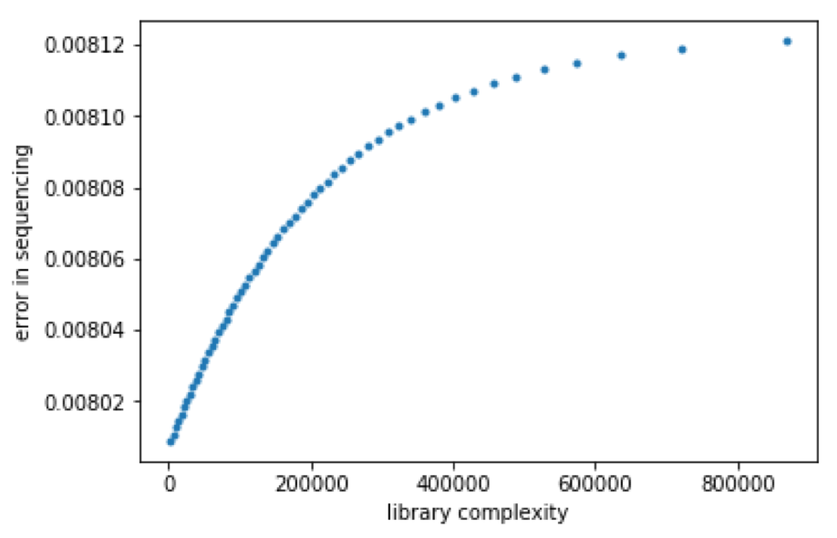

Check out the (name) Jupyter Notebook (running Python 3) for how I ran these simulations.

In my experiments, I aimed for having libraries with a complexity of at least 250,000. While having higher complexity isn’t super useful for fitness assays, it can definitely help with gene essentiality analysis

To increase library complexity:

* Use freshly transformed MFDλpir/pSC189 (use within a 4-5 days of transformation)
* Scale up accordingly. For some genetic backgrounds, increase number of large plates to spread libraries on (with the exception of REL11370, it’s not a major issue for most of the 50K LTEE isolates)

**Day 1**

Streak relevant strains

* MFDlpir/pSC189 on LB + DAP Kan 50ug/mL
* Recipient strain(s) on LB

**Day 2**

Start 2-3 mL overnight cultures each strain, scale up if more needed for matings (5 mL donor is sufficient for two recipient strains. If you need more, scale up). Grow shaking or rolling at 37C o/n (shoot for ~16 hours of growth at most)

**Day 3**

Wash cells

1. For each strain, spin 1 mL culture 15000 rpm x 1 minutes in eppendorfs. Pellet as many mls of donor as conjugations that you’re setting up.
2. Remove supernatant
3. Resuspend in 1 mL LB + DAP to wash
4. Spin again 15000 rpm x 2 minutes

Mate cells

1. Sterilize tweezers in 70% ethanol and flame
2. For each mating (Donor + Recipient) transfer a filter to a plate of normal LB + DAP
3. Placement doesn’t matter as long as they’re not touching
4. For each control (Donor only, Recipient only), transfer 1 filter to a plate of normal LB + DAP

Mate donor + recipient cells

1. Resuspend an eppendorf of donor in ~100ul of LB DAP
2. Transfer this to the pelleted recipient, resuspend the cells and transfer to the filter
3. Do this for each recipient.

For some recipients that don’t grow very well, I use ~2.5 mL of recipient overnight and this usually works well for me. Don’t do this as a default though.

For the controls, just plate donors and recipient directly on LB+Kan 50 or Kan 100 agar plates. Working quickly, transfer mating plates to 37C room while keeping plates upright to

avoid disturbing mating spots

1. Incubate plates upright (filters facing up) for 1 hour
2. Do not incubate for too long!

Plate libraries

1. During incubation, prepare 15 mL conicals with media for plating steps. Also prepare
2. 1.5 mL tubes for serial dilution.
3. Sterilize tweezers in 70% ethanol and flame
4. Transfer the filter from mating into a 15 mL conical tube containing 2 mL LB Kan50 (no DAP. Use same type of media that you will subsequently plate your libraries on). If you increase the number of filters, increase the liquid volume too.
5. Vortex the tube for 1 minute
6. Serially dilute 100 uL from tube across 900 uL LB Kan in 1.5 mL tubes
7. Plate 100 uL from -2, -3, and -4 dilutions onto normal sized LB Kan plates (effectively becomes -3, -4, and -5 dilutions to calculate library size)
8. Spread 300 uL each onto large LB plates (do a few preliminary experiments to get a sense of what the ballpark library complexity is for the genetic background of interest, and decide number of plates based on what complexity you’re looking for)

Incubate all plates at 30C

**Day 4 (morning)**

Try to grab plates in the morning and avoid incubating for too long - don’t want colonies on donor only or recipient only control. Calculate library size from dilution plates (original concentration in cfu/mL x volume plated out in mL)

Freeze library aliquots

1. Scrape cells from the large LB+Kan plates using a cell spreader, using ~4mL per plate.
2. Do this for all plates and pool together.
3. Add 50% glycerol such that the concentration of glycerol + transposon library is ~17%
4. Vortex and aliquot cells into 0.5 mL aliquots into 1.5 mL eppendorf tubes
5. Freeze aliquots at -80C, discard the rest unless more use of library is required

Estimate CFU and confirm exconjugants have transposon (in my experience, this is the most painful part of the process)

1. Scrape and thaw ~50 uL from a frozen aliquot and serially dilute in LB
2. Spread plate 100 uL of the 10^-5, 10^-6, 10^-7 dilutions on LB to determine viable counts (expect about ~10^9-10^10 CFU/mL, but some libraries are closer to 10^8. This is because those LTEE isolates often don’t grow very well on LB for some reason. If this is a concern, try incubating the plates at 37C. )
3. Next day count and patch ~100 CFU to LB Kan and LB to verify all clones are KanRand harbor transposon
4. Patch a KanS control colony to compare
5. Check to see how many of the clones are KanR, if not at least near 100%, redo experiment

**Troubleshooting inefficient kanamycin selection:**

* For some genetic backgrounds, the conjugation is super efficient, and we end up plating way too many cells for one Kan plate. Try reducing how many cells are plated on Kan. Rule of thumb in my experience is that you should reduce the volume you plate based on what fraction of patched colonies are kanS
* Even that isn’t sufficient for some genetic backgrounds. I have started plating on LB+Kan100 agar plates. This doesn’t affect growth of the conjugants in any way (I performed an MIC measurement, and they grow fine upto a concentration of Kan500), but dramatically improves the efficiency of selection
* Just keep trying a few times, getting a successful library is like a coin toss, and you should get something usable in 3-4 attempts.
* Pray to whatever/whoever you believe in, this step of the experiment just fucking sucks and you can only hope for the best

**References**

MFDλpir donor strain

Silent mischief: bacteriophage Mu insertions contaminate products of Escherichia coli

random mutagenesis performed using suicidal transposon delivery plasmids mobilized by

broad-host-range RP4 conjugative machinery.

Ferrieres et al. J Bac 2010

https://jb.asm.org/content/192/24/6418.long

pSC189

Construction of a mariner-based transposon for epitope-tagging and genomic targeting

Chiang et al. Gene 2002

https://www.sciencedirect.com/science/article/pii/S0378111902008569?via%3Dihub